Section 15 intermediate Javascript

[Randomness](https://www.youtube.com/watch?v=GtOt7EBNEwQ) -video by Khan Academy

* [Why can't programmers program?](https://blog.codinghorror.com/why-cant-programmers-program/) A blog past from Coding Horror
* [Now that's what I call a Hacker.](https://www.jitbit.com/alexblog/249-now-thats-what-i-call-a-hacker/) The legendary story retold in English.
* [The original story](https://bash.im/quote/436725) from above link in Russian.
* [Fibonacci challenge Flow Chart](https://drive.google.com/file/d/1g8vVtqhSj44vcElfc-HK0nMbecteW8Yg/view?usp=sharing)

BMI Calculator Advanced

Leap year

Arrays position, index start at 0

Length is 5

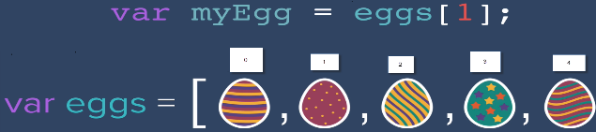

Array.includes() outputs bool

While loops

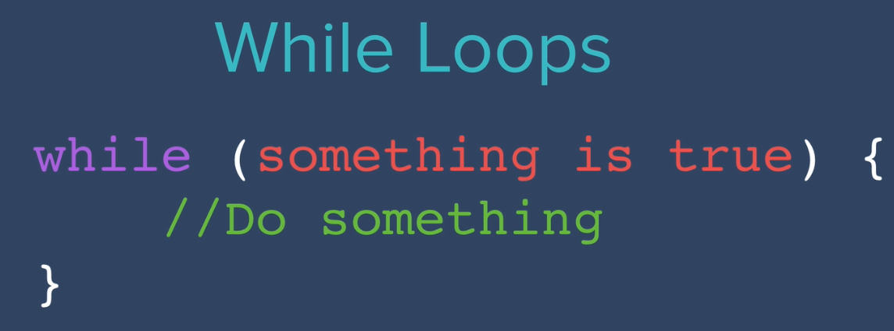

fibonacci

*function* fibonacciGenerator(*n*) {

  // n is number of items in sequence  so 3 would be [0,1,1]

  // fibonacci for this code starts at 1

*let* output = [];

  if (n === 1) {

    output = [0];

  } else if (n == 2) {

    output = [0, 1];

  } else {

    output = [0, 1];

    for (*let* i = 2; i < n; i++) {

      output.push(output[output.length - 2] + output[output.length - 1]);

    }

  }

  return output;

}